**Effectiveness of masks in the suppression of Covid-19 cases during the pandemic in India**

**Abstract**:

The pandemic ,caused by the SARS-CoV-2 virus, COVID-19 is the single greatest challenge faced by humanity in the 21st century. With the dramatic rise in cases during 2020 the world ,India included, had gone into lockdown as health experts and doctors scrambled to figure out effective ways to protect the population,face masks being one of them. This study intends to evaluate the effectiveness of face masks and face coverings in limiting the spread of the virus. The data for the number of cases was analyzed between the release of the face mask mandate on 1st April 2022 and its reinstatement on 21 st April 2022 in India. The prediction of cases dramatically increased after the face mask mandate was removed with an excess of 73353 cases over the predicted value from the previous month . A statistically significant (*p* = 0.001) positive correlation (0.969) was observed between the rate of cases and days when the mask mandate was removed. The study also showed the use of masks in reducing the spread of the virus during the first and second covid waves during 2020 and 2021 respectively by taking into considerations the rate of increase in cases per state Thus it is concluded that masks help in diminishing the spread of the novel coronavirus in India.

1. Introduction

The COVID-19 outbreak has spread to 228 Countries and Territories around the world which have reported a total of 561,788,869 confirmed cases , and a death toll of 6,374,783 .[**3**]. India has the second largest number of confirmed cases and deaths with 43,652,944 cases and 525,474 deaths recorded as of July 12 th 2022 [1]. There are many methods to prevent the spread of the virus,the imposition of a countrywide lockdown plays a very important role in restraining the spread of the disease. By increasing the amount of distance between people we can, significantly reduce the rate of transmission of the disease The disease is mainly transmitted through ejected respiratory droplets (>5 μm), smaller aerosols (<5 μm), and direct contact with an infected person [[**4**](https://www.mdpi.com/1660-4601/18/7/3666/htm#B4-ijerph-18-03666)].which can be spread by asymptomatic,pre symptomatic or patients with symptoms [[**5**](https://www.mdpi.com/1660-4601/18/7/3666/htm#B5-ijerph-18-03666),[**6**](https://www.mdpi.com/1660-4601/18/7/3666/htm#B6-ijerph-18-03666),[**7**](https://www.mdpi.com/1660-4601/18/7/3666/htm#B7-ijerph-18-03666)] through coughs or sneezes[[**4**](https://www.mdpi.com/1660-4601/18/7/3666/htm#B4-ijerph-18-03666)].which is why social distancing and face coverings play an important role in prevention of its spread.With respect to environmental factors that affect the spread of the virus. Studies found a positive association between new cases with temperature from mid march to april and . a negative association between relative and absolute humidity and the rise in cases in India[8]. Since the virus spreads via aerosols the reduction in concentrations of aerosols in the air during the first lockdown during the first may also be a reason for the drop in covid cases[8].

Social distancing has also been a critical tool in mitigation of the spread of the virus.

The outdoors is a safer option if you wish to socialize with persons who don't live with you. Even without the use of masks, you are less likely to be exposed to COVID-19 while engaging in outdoor activities.You can avoid catching and transmitting COVID-19 by having adequate airflow.Avoiding crowded areas when possible to remain 6 feet away from other people is important as well.[10] The length and timing of the relaxation or termination of the tight social-distancing measures will have a significant impact on how the COVID-19 epidemic develops in the future. This analysis demonstrates that the implementation of strong social-distancing measures too soon could result in a devastating second wave that would carry a burden similar to that which was anticipated prior to the implementation of such policies.[9].A study discovered evidence that suggests with a degree of reasonable certainty that present policies of at least 1 m physical separation are probably related with a significant reduction in infection, and that intervals of 2 m may be more beneficial, as implemented in some countries.. Physical barriers provide the main advantage of preventing further transmission, which lessens the negative effects of SARS-CoV-2 infection. The findings of this research thus justify the implementation of a policy requiring a physical distance of at least 1 m and, if practical, 2 m or more. Our research also offers reliable estimates that can be incorporated into contact tracing models and planning strategies for pandemic response activities at various levels.[9,11,12].

Despite social distancing being widely adopted and face mask being mandated to prevent the spread of the virus,there is still some doubt that lingers in the minds of the populace regarding the use the face masks.In a survey of the indian populous more 37% of people were ,27% ‘not sure’ 10% ‘no’ - were on the fence about taking the vaccine and the majority (71%) had concerns with regards to the COVID-19 vaccines[28].Disparities were found among the general population and in community settings, despite the recommendation that symptomatic people and those in healthcare settings utilize face masks.[13,14,15]For dental use during patient care, N95 or FFP2 respirators are advised as part of PPE. It is advised to use a surgical mask in addition to a face mask to extend the lifespan of respiratory masks. Similarly, it is crucial to provide a proper fit and hermetic seal against the skin when applying the mask.For dental use during patient care, N95 or FFP2 respirators are advised as part of PPE. It is advised to use a surgical mask in addition to a face mask to extend the lifespan of respiratory masks. Similarly, it is crucial to provide a proper fit and hermetic seal against the skin when applying the mask.[17]

Particularly in terms of the relative contributions of contact vs airborne transmission channels to the COVID-19 pandemic, the disease's transmission mechanisms are not entirely known. [16,18] attempts have been made towards understanding the effectiveness of face coverings against the spread of COVID-19. However, analysis is often carried out using mathematical and empirical modeling approaches [19,20], simulation experiments [21], and participatory surveys [22,23]. In the current study, actual confirmed cases data were included in the analysis. We examined the effectiveness of face coverings as a mitigating measure by measuring the rise in rate of new daily cases and cumulative cases in India during the month of april 2022 when the mask mandate was removed and the cause of the wave caused in April 2021 when people drastically reduced the usage of face masks .

1. Results and explanations

2.1 The effect of mask mandate removal April 2022

Following the drop in rate of daily cases the indian government called for a drop in the mask mandates.With over 988.85 million people in the country vaccinated 831.24 million of those being fully vaccinated on 31st march[27] being one of the prime reasons for the decline in cases COVID-19 vaccinations that provide sterilizing immunity seem to reduce the size of potential infection waves in the future. The greatest reduction in mortality occurs when option 4 (i.e., prioritizing individuals under 60 years old) is used, but all vaccination strategies result in appreciable gains when compared to no immunization[29]. .States like Delhi ,Maharashtra and Telangana completely got rid of the requirements of masks in public [25,26,41] .After this there was a clear increase in the number of daily new cases and the rate of growth of cumulative cases across the nation.

The rate of daily cases from march 1st to march 31st was in the negatives with a slope of .-193.27408231 which indicates a drop in about 193 cases everyday.During the month of april from April 1st till April 25th when the mask mandate was reinstated[30] , the number of cases saw a spike with a slope of +93.06453202 i.e a rise in the number of cases by about 93 new cases a day.Following the reinstated mandate , the number of cases during the month of May 2022 saw a drop with the slope being -34.03403782 a drop in cases by 34 a day.The data for cumulative cases for the month of march 2022 and april 2022 were compared as well .The data showed that the growth rate of cumulative cases for India in the month of march was at around 2033 cases a day compared to the month of April which was 2134 cases a day showing an increase in the rate of cases during that month compared to the month of March. These assessments are justified by the high value of Coefficient of Determination (0.94052) between the date and the number of cumulative cases.

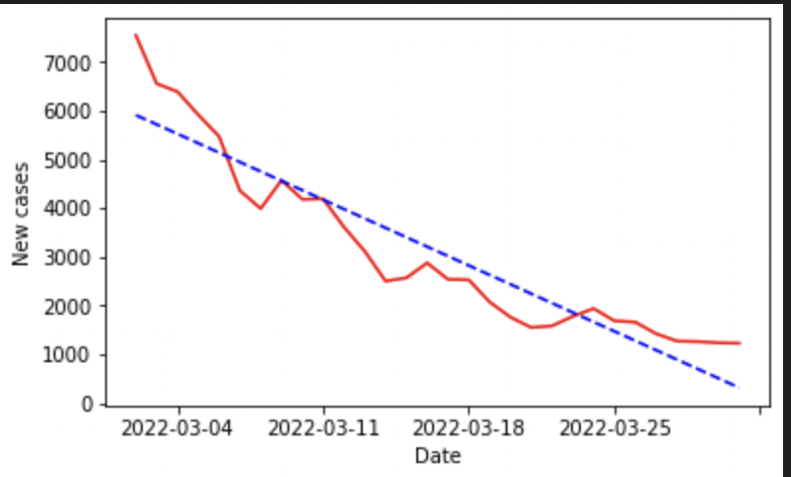

Figure 1:graph showing Daily new cases by date for before the removal of the mask mandate from 01-03-2020 till 30-03-2020

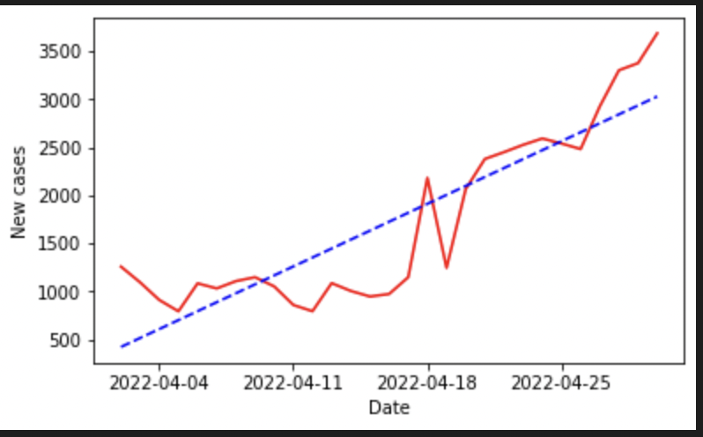

Figure 2:graph showing Daily new cases by date after the removal of the mask mandate from 01-04-2022 to 25-04-2022

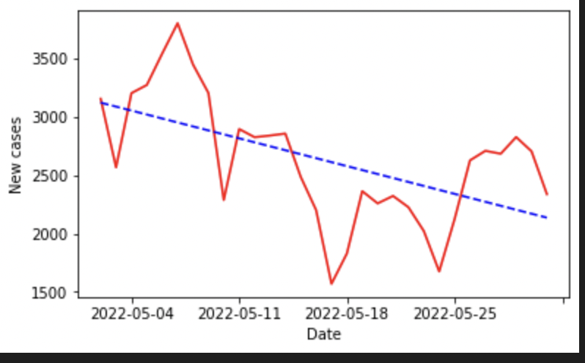

Figure 3:graph showing Daily new cases by date after the reinstatement of the mask mandate from 01-05-2022 to 01-06-2022

2.1.1 Prediction of cases vs Actual cases

The number of cumulative cases for the month of march were taken into consideration to make a prediction on the number of cases during the month of April.

The linear regression prediction of the number of cases was much lesser than the actual number of cases during the month of April .The coefficient of determination for the date vs cumulative case count graph (0.9405)is very high, affirming the correctness of the prediction made.The maximum difference between the predicted value for the cases and the actual values was about 73353 people .The Pearson’s correlation between the number of cases and date for significant (p=0.001) was 0.97 showing that the correlation between the rate of cases increase with the passage of days was positive i.e the removal of mask mandate caused and increase in the number of cases.

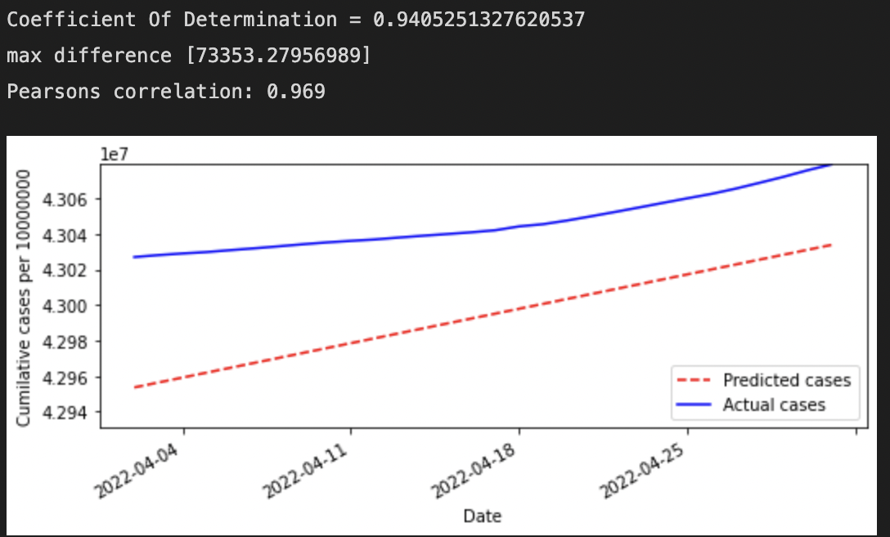

Figure 4:Graph showing the number of cumulative cases by date for the month of April 2022 during which the mask mandate was removed ,The blue curve indicates the actual cumulative cases for the month and the red line indicates the predicted value for cases calculated using data from the previous month.

2.2 Analysis of face mask in reduction of cases

Analysis was done to see the effect of face masks during the two spikes in number of covid cases during the first wave(June - October 2020) and second wave(March - July 2021) of covid.We compared the data of states in India during these waves of covid and determined the relation of number of confirmed cases with the dates to see how face masks reduced the spread of the virus and reduced the number of cases by comparing the slope values for different states.

A negative slope indicates a drop in the number of cases but since the data only contains confirmed cases the number can only increase or decrease till 0 and never be negative.Smaller slopes values for the confirmed cases(y axis) and date(x axis) indicate lower infection rates.The study compares the data for slope values of states before and after the peaks of the second and first waves of covid to show how mask wearing states had a quicker drop in the rate of covid infection during these waves

2.2.1 June - December 2020 first wave

The first wave of covid started during the early months of 2020 and the initial lockdown was announced on 24 th March 2020 when there was an initial rise in cases.[31,32] The government established a complete lockdown which was further extended until the 31 st of may after which they announced the beginning of the “unlock” phases to relieve restrictions .It consisted of 7 parts from unlock 1.0 to unlock 7.0 each reducing social interaction restrictions a little more than its previous counterpart until the final unlock 7.0 in December of 2020[33].

Hence for the first lockdown values for cumulative cases were only taken for dates from 1st June after the first “Unlock 1.0”.The data was split into two parts, before the peak and after the peak for a period of 212.The top ten states with highest values of slopes were MH,AP,KA,TN,WB,BH,DL,GJ,AS,OD with values 10769 , 5503 , 5618, 4441 , 3371 , 3003 ,2928,2035,1427,1329 respectively.

The top ten states with the lowest values were TR, MN,CH, AR, ML, NL, SK, AN, MZ, DN-DD with values 240,206,150,112,104,76,66,31,29,23,19 respectively.Of these states the order of highest and lowest is mainly due the population density of the states [40]so considering the lower values is not a good representation of the spread hence only those states with the highest values are considered.Of the top 10 states KL,DL,WB,OD had values higher after the country peak(15 th June 2020) the states MH,KA,AP,TN,ASand GJ all have slopes before the peak values less than those after .These states have shown more strict adherence to the mask protocol[34,35,36,37,38,39] than the former states which is reflected in the the reduced after peak slope values .

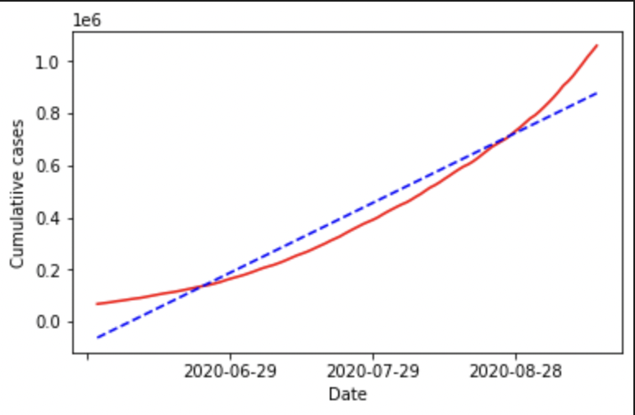

Figure 1:graph showing cumulative cases by date for the state Maharashtra (MH) before the peak of the first wave from 01-06-2020 till 15-09-2020

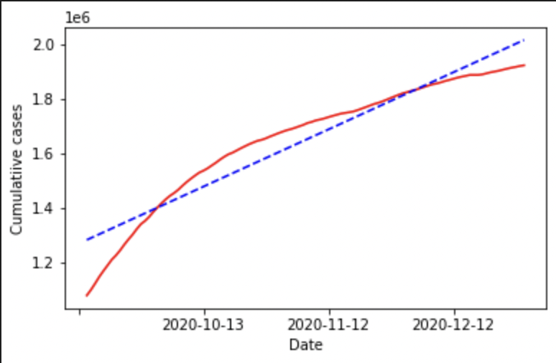

Figure 2:graph showing cumulative cases by date for the state Maharashtra (MH) after the peak of the first wave on 15-09-2020 till 30-12-2020

2.2.2 March - September Second wave

The second wave of covid occurred during the months of March to September.The main causes for the second wave were due to people reducing the usage of masks in the country due to the drop in daily cases to very low numbers making people less weary despite being warned of a second wave being imminent.According to surveys by the government half the population did not wear face [42] .This along with the new mutation of the SARS-COV-2 virus (Delta variant) which infected at an even greater rate than its previous version caused a much more massive spike in the number of cases this time around[43].The data was split into two parts, before the peak and after the peak for a period of 212.The top ten states with highest values of slopes were MH , KA, KL, TN, UP,AP,WB,DL,OD,GJ with values 36563,19477,18480,16153,11706, 10122,9530,8349 , 5717 ,5695 respectively .Of these states the order of highest and lowest is mainly due the population density of the states [40]so considering the lower values is not a good representation of the spread hence only those states with the highest values are considered.Considering the top 10 states KL,DL,WB,OD had values higher after the country peak(15 th June 2020) the statesMH,KA,KL,TN,AP,WB,OD and GJ all have slopes values before the peak values less than the slope values after the peak .These states have shown more strict adherence to the mask protocol[34,35,36,37,38,39] compared to the states of DL and UP.

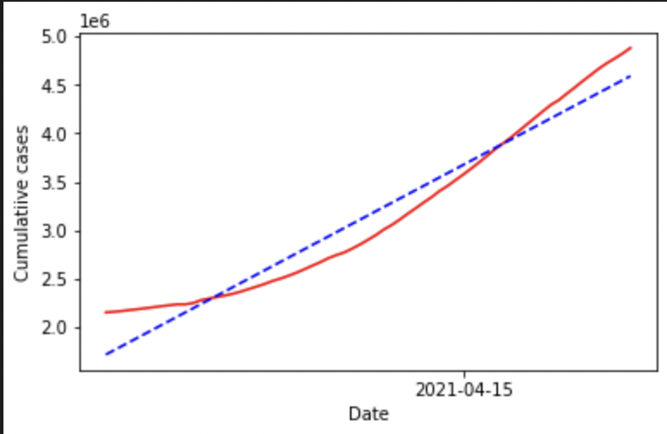

Figure 3:graph showing cumulative cases by date for the state Maharashtra (MH) before the peak of the first wave from 01-03-2021 till 07-05-2021

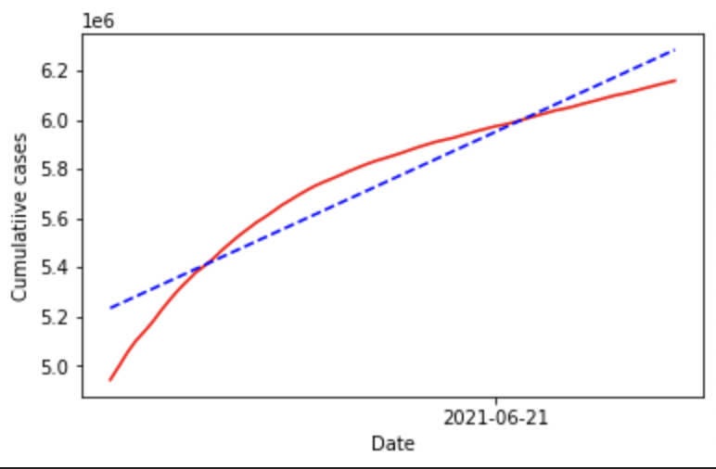

Figure 4:graph showing cumulative cases by date for the state Maharashtra (MH) before the peak of the first wave from 07-05-2020 till 13-07-2020

2.2.3 Both Waves summarized

The first and second waves of covid provide a great insight into the effectiveness of masks in the reduction of cases Most of the states that mandated maks and regulated them strictly saw a greater reduction in number of cases over the duration of both the waves.The second wave showed the functionality of masks from both sides ,the lack of use of masks aiding in the mass spread and sudden growth in the number of infections per day (174989 slope for IN 2nd wave) as compared to the 1st wave(58558) which is almost a third of the 2nd wave’s slope due to the fact that people were more cautious and wore masks diligently during the first wave , and the policing of masks after the fact during the wave to reduce its spread in major states.

2.3 Correlation between New cases and days since mandate removal

The removal of the mask mandate in April 1st 2022 is proven to cause the growth in the number of cases by plotting a scatter plot of number of daily new cases since april 1st till the date the mandate was reinstated on april 25 th.The dates were placed on the x axis of the graph and the Number of new cases per day were indicated by the y axis and pearson's correlation between the two variables were calculated .The results of the analysis of the showed a positive correlation (+0.876) was discovered indicating that the days removal of mask mandate had a direct impact on the increase in the number of daily cases.Further statistical analysis showed(t=2.048407141795244,df=28,p=4.5085488e-10, confidence of 95%(10.81751546148327,17.182484538516732)).Which indicates that the number of daily new cases increases with each day after the date for removal of mask mandate

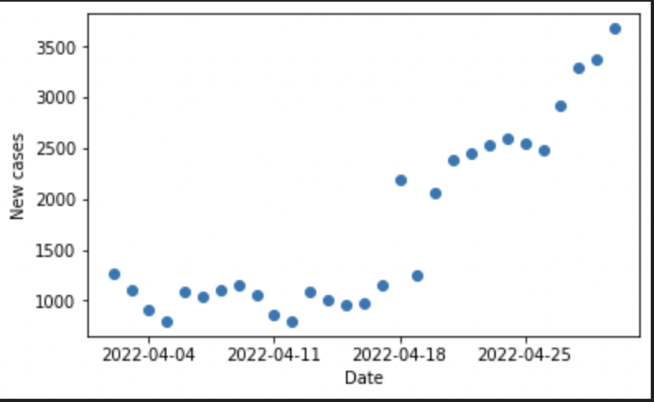

Figure 1 Scatter plot showing correlation between the Number of new cases daily vs date for the month of April 2022 .The plot shows a positive correlation of 0.876

The mask mandate was reinstated on April 25 th 2022 to prove that the mask mandate caused a decline in cases. We analyzed the following month by plotting a scatter plot for the New cases and the days since the mandate’s reinstatement till June 1st 2022. The analysis showed a negative correlation(-0.592)This was backed a statistically significant (t=2.0301079282503425 , df=35 , p=0.00014120162565199102 , confidence of 95% [13.985106763170227,21.01489323682977]).This showed that as the number of days since the reinstatement of the mask mandate increases the number daily new cases decreases

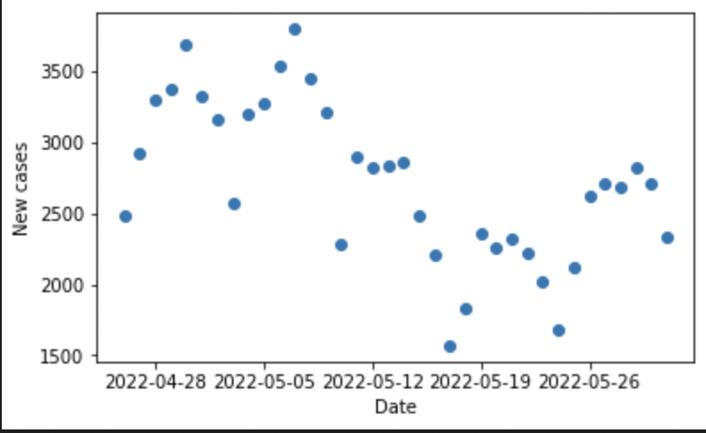

Figure 2 Scatter plot showing the correlation between number of new cases daily vs the date for the month of May 2022 since the reinstatement of the mask mandate.The plot shows a negative correlation of -0.592.

References

43.<https://www.hopkinsmedicine.org/health/conditions-and-diseases/coronavirus/first-and-second-waves-of-coronavirus>

44.<https://www.hindustantimes.com/india-news/delta-variant-primarily-responsible-for-covid-19-second-wave-says-govt-expert-101626689924076.html>

34. <https://www.ndtv.com/india-news/ajit-pawar-maharashtra-considering-rs-1-000-fine-for-not-wearing-masks-in-some-areas-2286996>

35.<https://www.thehindu.com/news/national/karnataka/wearing-of-masks-made-mandatory-in-bengaluru/article31483806.ece>

36.<https://timesofindia.indiatimes.com/city/visakhapatnam/wearing-mask-compulsory-in-public-places-in-andhra-pradesh-now/articleshow/77029023.cms>

37. Polani Chandrasekar, Rubeshkumar & Id, Mohankumar & Sakthivel, Manikandanesan & Muraliid, Sharan & Nagarajan, Ramya & Sendhilkumar, Muthappan & Sambath, Irene & Ilangovan, Kumaravel & Harikrishnanid, Dineshkumar & Venkatasamy, Vettrichelvan & Ganeshkumar, Parasuraman & Reddy, Madhusudhan & Kaur, Prabhdeep. (2021). Surveillance for face mask compliance, Chennai, Tamil Nadu, India, October-December, 2020. PLoS ONE. 16. 10.1371/journal.pone.0257739. <https://www.researchgate.net/publication/354820606_Surveillance_for_face_mask_compliance_Chennai_Tamil_Nadu_India_October-December_2020>

38.<https://www.eastmojo.com/news/2020/05/24/assam-police-collect-over-rs-27-lakh-as-fine-for-not-wearing-masks/>

39.<https://indianexpress.com/article/india/gujarat-govt-approaches-sc-against-hcs-mask-order/>

32.<https://economictimes.indiatimes.com/news/india/one-year-since-a-complete-lockdown-was-announced-we-look-back-on-how-india-fought-covid/first-lockdown-announced/slideshow/81662838.cms>

31. The Lancet. India under COVID-19 lockdown. Lancet. 2020 Apr 25;395(10233):1315. doi: 10.1016/S0140-6736(20)30938-7. PMID: 32334687; PMCID: PMC7180023.

<https://doi.org/10.1016%2FS0140-6736(20)30938-7>

33.<https://hindi.careerindia.com/news/unlock-7-0-guidelines-in-hindi-for-december-2020-002841.html>

30[://www.hindustantimes.com/india-news/mask-mandatory-rule-is-back-states-uts-which-made-it-compulsory-101650898622625.html](https://www.hindustantimes.com/india-news/mask-mandatory-rule-is-back-states-uts-which-made-it-compulsory-101650898622625.html)

28. Sneha Chandani, Deepti Jani, Pratap Kumar Sahu, Udichi Kataria, Shailendra Suryawanshi, Jagdish Khubchandani, Sanket Thorat, Sohan Chitlange, Dharmendra Sharma,

COVID-19 vaccination hesitancy in India: State of the nation and priorities for research,

Brain, Behavior, & Immunity - Health,

Volume 18,

2021,

100375,

ISSN 2666-3546,

<https://doi.org/10.1016/j.bbih.2021.100375>.

<https://www.sciencedirect.com/science/article/pii/S2666354621001782>

29. Brody H. Foy, Brian Wahl, Kayur Mehta, Anita Shet, Gautam I. Menon, Carl Britto,

Comparing COVID-19 vaccine allocation strategies in India: A mathematical modelling study,

International Journal of Infectious Diseases,

Volume 103,

2021,

Pages 431-438,

ISSN 1201-9712,

<https://doi.org/10.1016/j.ijid.2020.12.075>.

<https://www.sciencedirect.com/science/article/pii/S1201971220325996>

1.<https://www.worldometers.info/coronavirus/countries-where-coronavirus-has-spread/>

19. Eikenberry, S.E.; Mancuso, M.; Iboi, E.; Phan, T.; Eikenberry, K.; Kuang, Y.; Kostelich, E.; Gumel, A.B. To mask or not to mask: Modeling the potential for face mask use by the general public to curtail the COVID-19 pandemic. *Infect. Dis. Model.* **2020**, *5*, 293–308. [[**Google Scholar**](https://scholar.google.com/scholar_lookup?title=To+mask+or+not+to+mask:+Modeling+the+potential+for+face+mask+use+by+the+general+public+to+curtail+the+COVID-19+pandemic&author=Eikenberry,+S.E.&author=Mancuso,+M.&author=Iboi,+E.&author=Phan,+T.&author=Eikenberry,+K.&author=Kuang,+Y.&author=Kostelich,+E.&author=Gumel,+A.B.&publication_year=2020&journal=Infect.+Dis.+Model.&volume=5&pages=293%E2%80%93308&doi=10.1016/j.idm.2020.04.001)] [[**CrossRef**](https://doi.org/10.1016/j.idm.2020.04.001)]

21. Aydin, O.; Emon, B.; Cheng, S.; Hong, L.; Chamorro, L.P.; Saif, M.T.A. Performance of fabrics for home-made masks against the spread of COVID-19 through droplets: A quantitative mechanistic study. *Extrem. Mech. Lett.* **2020**, *40*, 100924. [[**Google Scholar**](https://scholar.google.com/scholar_lookup?title=Performance+of+fabrics+for+home-made+masks+against+the+spread+of+COVID-19+through+droplets:+A+quantitative+mechanistic+study&author=Aydin,+O.&author=Emon,+B.&author=Cheng,+S.&author=Hong,+L.&author=Chamorro,+L.P.&author=Saif,+M.T.A.&publication_year=2020&journal=Extrem.+Mech.+Lett.&volume=40&pages=100924&doi=10.1016/j.eml.2020.100924)] [[**CrossRef**](https://doi.org/10.1016/j.eml.2020.100924)]

22. Sickbert-Bennett, E.E.; Samet, J.M.; Clapp, P.W.; Chen, H.; Berntsen, J.; Zeman, K.L.; Tong, H.; Weber, D.J.; Bennett, W.D. Filtration Efficiency of Hospital Face Mask Alternatives Available for Use During the COVID-19 Pandemic. *JAMA Intern. Med.* **2020**, *180*, 1607. [[**Google Scholar**](https://scholar.google.com/scholar_lookup?title=Filtration+Efficiency+of+Hospital+Face+Mask+Alternatives+Available+for+Use+During+the+COVID-19+Pandemic&author=Sickbert-Bennett,+E.E.&author=Samet,+J.M.&author=Clapp,+P.W.&author=Chen,+H.&author=Berntsen,+J.&author=Zeman,+K.L.&author=Tong,+H.&author=Weber,+D.J.&author=Bennett,+W.D.&publication_year=2020&journal=JAMA+Intern.+Med.&volume=180&pages=1607&doi=10.1001/jamainternmed.2020.4221)] [[**CrossRef**](https://doi.org/10.1001/jamainternmed.2020.4221)]

23. Iversen, B.G.; Vestrheim, D.F.; Flottorp, S.; Denison, E.; Oxman, A.D. *COVID-19 (2020) Should Individuals in the Community without Respiratory Symptoms Wear Facemasks to Reduce the Spread of COVID-19?* Norwegian Institute of Public Health: Oslo, Norway, 2020.

18. Yixin Li, Renyi Zhang, Jiayun Zhao, Mario J. Molina,

Understanding transmission and intervention for the COVID-19 pandemic in the United States,

Science of The Total Environment,

Volume 748,

2020,

141560,

ISSN 0048-9697,

<https://doi.org/10.1016/j.scitotenv.2020.141560> .

<https://www.sciencedirect.com/science/article/pii/S0048969720350890>

16. R. Zhang, Y. Li, A.L. Zhang, Y. Wang, M.J. Molina

Identifying airborne transmission as the dominant route for the spread of COVID-19

Proc. Natl. Acad. Sci. U. S. A., 117 (2020), pp. 14857-14863, 10.1073/pnas.2009637117

<https://doi.org/10.1073/pnas.2009637117>

13.WHO

Coronavirus disease (COVID-19) advice for the public: when and how to use masks.

<https://www.who.int/emergencies/diseases/novel-coronavirus-2019/advice-for-public/when-and-how-to-use-masks>

14.CDC

Coronavirus Disease 2019 (COVID-19): steps to prevent illness.

<https://www.cdc.gov/coronavirus/2019-ncov/about/prevention-treatment.html>

15.WHO

Shortage of personal protective equipment endangering health workers worldwide.

<https://www.who.int/news-room/detail/03-03-2020-shortage-of-personal-protective-equipment-endangering-health-workers-worldwide>

Hannah Ritchie, Edouard Mathieu, Lucas Rodés-Guirao, Cameron Appel, Charlie Giattino, Esteban Ortiz-Ospina, Joe Hasell, Bobbie Macdonald, Diana Beltekian and Max Roser (2020) - "Coronavirus Pandemic (COVID-19)". Published online at OurWorldInData.org. Retrieved from: '<https://ourworldindata.org/coronavirus>' [Online Resource]

3.<https://www.who.int/emergencies/diseases/novel-coronavirus-2019>

<https://covid19.who.int/data>

The Lancet. India under COVID-19 lockdown. Lancet. 2020 Apr 25;395(10233):1315. doi: 10.1016/S0140-6736(20)30938-7. PMID: 32334687; PMCID: PMC7180023.

Karia, R., Gupta, I., Khandait, H. et al. COVID-19 and its Modes of Transmission. SN Compr. Clin. Med. 2, 1798–1801 (2020). https://doi.org/10.1007/s42399-020-00498-4

* Accepted
* 28 August 2020
* Published
* 01 September 2020
* Issue Date
* October 2020
* DOI
* <https://doi.org/10.1007/s42399-020-00498-4>
* <https://link.springer.com/article/10.1007/s42399-020-00498-4>

<https://www.mohfw.gov.in>

25 Mar 2020 – 31 May 2020 -lockdown dates india

<https://en.wikipedia.org/wiki/COVID-19_lockdown_in_India>

25. <https://www.hindustantimes.com/india-news/list-of-states-where-covid-19-mask-not-mandatory-anymore-explained-101648789690816.html> delhi maharashtra remove mask mandate march 31st

26. <https://www.livemint.com/news/india/covid19-update-states-where-covid-19-mask-not-mandatory-anymore-what-experts-have-to-say-11648797250096.html>

27. Mathieu, E., Ritchie, H., Ortiz-Ospina, E. et al. [A global database of COVID-19 vaccinations. Nat Hum Behav (2021)](https://doi.org/10.1038/s41562-021-01122-8)

17.Arellano-Cotrina, J., Marengo-Coronel, N., Atoche-Socola, K., Peña-Soto, C., & Arriola-Guillén, L. (2021). Effectiveness and Recommendations for the Use of Dental Masks in the Prevention of COVID-19: A Literature Review. Disaster Medicine and Public Health Preparedness, 15(5), E43-E48. doi:10.1017/dmp.2020.255

<https://www.cambridge.org/core/journals/disaster-medicine-and-public-health-preparedness/article/effectiveness-and-recommendations-for-the-use-of-dental-masks-in-the-prevention-of-covid19-a-literature-review/B822703122723B2D5E48F1EDF60ACD63>

Yanni Li, Mingming Liang, Liang Gao, Mubashir Ayaz Ahmed, John Patrick Uy, Ce Cheng, Qin Zhou, Chenyu Sun,

Face masks to prevent transmission of COVID-19: A systematic review and meta-analysis,

American Journal of Infection Control,

Volume 49, Issue 7,

2021,

Pages 900-906,

ISSN 0196-6553,

<https://doi.org/10.1016/j.ajic.2020.12.007>.

<https://www.sciencedirect.com/science/article/pii/S0196655320310439>

40. Joacim Rocklöv, PhD, Henrik Sjödin, PhD, High population densities catalyze the spread of COVID-19, Journal of Travel Medicine, Volume 27, Issue 3, April 2020, taaa038, <https://doi.org/10.1093/jtm/taaa038>

Li, Y, Ren, B, Peng, X, et al. Saliva is a non-negligible factor in the spread of COVID-19. Mol Oral Microbiol. 2020; 35: 141– 145. <https://doi.org/10.1111/omi.12289>

8. Sarvan Kumar,

Effect of meteorological parameters on spread of COVID-19 in India and air quality during lockdown,

Science of The Total Environment,

Volume 745,

2020,

141021,

ISSN 0048-9697,

<https://doi.org/10.1016/j.scitotenv.2020.141021>.

<https://www.sciencedirect.com/science/article/pii/S0048969720345502>

3. Roy, Sudipto and Roy Bhattacharya, Kankana, Spread of COVID-19 in India: A Mathematical Model (April 28, 2020). Available at SSRN: <https://ssrn.com/abstract=3587212> or [http://dx.doi.org/10.2139/ssrn.3587212](https://dx.doi.org/10.2139/ssrn.3587212)

Chiranjib Chakraborty, Ashish Ranjan Sharma, Manojit Bhattacharya, Govindasamy Agoramoorthy, Sang-Soo Lee,

The current second wave and COVID-19 vaccination status in India,

Brain, Behavior, and Immunity,

Volume 96,

2021,

Pages 1-4,

ISSN 0889-1591,

<https://doi.org/10.1016/j.bbi.2021.05.018>.

<https://www.sciencedirect.com/science/article/pii/S0889159121001999>

<https://www.kaggle.com/datasets/sudalairajkumar/covid19-in-india?resource=download>

41.<https://www.cntraveller.in/story/these-indian-states-are-back-with-mask-mandates-delhi-haryana-uttar-pradesh-chandigarh/> mask mandate dropped

25. Panda, Samiran1,#; Kaur, Harkiran3; Dandona, Lalit3,†; Bhargava, Balram2,* Face mask - An essential armour in the fight of India against COVID-19, Indian Journal of Medical Research: Jan–Feb 2021 - Volume 153 - Issue 1-2 - p 233-237

<https://doi.org/10.4103/ijmr.ijmr_4486_20>

5.Rab, S.; Javaid, M.; Haleem, A.; Vaishya, R. Face masks are new normal after COVID-19 pandemic. *Diabetes Metab. Syndr. Clin. Res. Rev.* **2020**, *14*, 1617–1619. [[**Google Scholar**](https://scholar.google.com/scholar_lookup?title=Face+masks+are+new+normal+after+COVID-19+pandemic&author=Rab,+S.&author=Javaid,+M.&author=Haleem,+A.&author=Vaishya,+R.&publication_year=2020&journal=Diabetes+Metab.+Syndr.+Clin.+Res.+Rev.&volume=14&pages=1617%E2%80%931619&doi=10.1016/j.dsx.2020.08.021&pmid=32889402)] [[**CrossRef**](https://doi.org/10.1016/j.dsx.2020.08.021)] [[**PubMed**](https://www.ncbi.nlm.nih.gov/pubmed/32889402)]

6.Rothe, C.; Schunk, M.; Sothmann, P.; Bretzel, G.; Froeschl, G.; Wallrauch, C.; Zimmer, T.; Thiel, V.; Janke, C.; Guggemos, W.; et al. Transmission of 2019-nCoV Infection from an Asymptomatic Contact in Germany. *N. Engl. J. Med.* **2020**, *382*, 970–971. [[**Google Scholar**](https://scholar.google.com/scholar_lookup?title=Transmission+of+2019-nCoV+Infection+from+an+Asymptomatic+Contact+in+Germany&author=Rothe,+C.&author=Schunk,+M.&author=Sothmann,+P.&author=Bretzel,+G.&author=Froeschl,+G.&author=Wallrauch,+C.&author=Zimmer,+T.&author=Thiel,+V.&author=Janke,+C.&author=Guggemos,+W.&publication_year=2020&journal=N.+Engl.+J.+Med.&volume=382&pages=970%E2%80%93971&doi=10.1056/NEJMc2001468)] [[**CrossRef**](https://doi.org/10.1056/NEJMc2001468)]

7.Pan, X.; Chen, D.; Xia, Y.; Wu, X.; Li, T.; Ou, X.; Zhou, L.; Liu, J. Asymptomatic cases in a family cluster with SARS-CoV-2 infection. *Lancet Infect. Dis.* **2020**, *20*, 410–411. [[**Google Scholar**](https://scholar.google.com/scholar_lookup?title=Asymptomatic+cases+in+a+family+cluster+with+SARS-CoV-2+infection&author=Pan,+X.&author=Chen,+D.&author=Xia,+Y.&author=Wu,+X.&author=Li,+T.&author=Ou,+X.&author=Zhou,+L.&author=Liu,+J.&publication_year=2020&journal=Lancet+Infect.+Dis.&volume=20&pages=410%E2%80%93411&doi=10.1016/S1473-3099(20)30114-6)] [[**CrossRef**](https://doi.org/10.1016/S1473-3099(20)30114-6)]

9. Calistus N. Ngonghala, Enahoro Iboi, Steffen Eikenberry, Matthew Scotch, Chandini Raina MacIntyre, Matthew H. Bonds, Abba B. Gumel,

Mathematical assessment of the impact of non-pharmaceutical interventions on curtailing the 2019 novel Coronavirus,

Mathematical Biosciences,

Volume 325,

2020,

108364,

ISSN 0025-5564,

<https://doi.org/10.1016/j.mbs.2020.108364>.

<https://www.sciencedirect.com/science/article/pii/S0025556420300560>

10. <https://www.cdc.gov/coronavirus/2019-ncov/your-health/gatherings.html>

11. Akhil Kumar Srivastav, Pankaj Kumar Tiwari, Prashant K Srivastava, Mini Ghosh, Yun Kang. A mathematical model for the impacts of face mask, hospitalization and quarantine on the dynamics of COVID-19 in India: deterministic vs. stochastic[J]. Mathematical Biosciences and Engineering, 2021, 18(1): 182-213.

doi: 10.3934/mbe.2021010 <http://aimspress.com/article/doi/10.3934/mbe.2021010>

12. **Physical distancing, face masks, and eye protection to prevent person-to-person transmission of SARS-CoV-2 and COVID-19: a systematic review and meta-analysis**Chu, Derek KChu, Derek K et al.  
The Lancet, Volume 395, Issue 10242, 1973 - 1987

<https://doi.org/10.1016/S0140-6736(20)31142-9>

42<https://www.hindustantimes.com/india-news/covid19-half-the-indian-population-do-not-wear-mask-says-govt-101621512213896.html>

20. Stutt, R.O.J.H.; Retkute, R.; Bradley, M.; Gilligan, C.A.; Colvin, J. A modelling framework to assess the likely effectiveness of facemasks in combination with ‘lock-down’ in managing the COVID-19 pandemic. *Proc. R. Soc. A Math. Phys. Eng. Sci.* **2020**, *476*, 20200376

<https://doi.org/10.1098/rspa.2020.0376>

**24. Second wave of COVID-19 pandemic in India: Barriers to effective governmental response**Kar, Sujita Kumar et al.  
eClinicalMedicine, Volume 36, 100915

<https://doi.org/10.1016/j.eclinm.2021.100915>